

Lab 5: Load Cell

Instructor: Rameez Ashraf

  - SMRTTECH 3CC3
  - Cloud Computing and Internet of Things
  - B. Tech - SMRTTECH

Submitted by: Nicolas Jao - 400450151
Partner (s): Jacob Kwan – 400453713 (sick this week)
Lab Section: L04
Date of lab: September 29, 2025

Abstract
In this experiment, a force sensor was used to transduce applied mechanical force into an electrical voltage, and successive signal conditioning stages were added via operational amplifiers to improve the signal’s usability. First, the raw sensor output was measured by connecting the force sensor in a voltage divider and reading the voltage with an Arduino’s analog input; the sensor’s voltage response to varying applied forces was recorded and characterized. Next, a first op-amp stage was introduced to amplify the small sensor voltage; the amplified output was measured for the same applied force levels, and the gain, linearity, and noise behavior were compared. A second op-amp stage was then cascaded and again the voltage output was measured across the force range to evaluate improvements in signal amplitude, signal-to-noise ratio, and stability. Finally, a LabVIEW program (running in tandem with custom Arduino firmware) continuously monitored the conditioned voltage, and displayed a real-time indicator on the front panel. The results demonstrate how incremental amplification and conditioning transform a weak sensor signal into a robust, usable measurement, and validate that the LabVIEW/Arduino system can reliably detect and display force levels in real time.

Results & Discussions
- Results:
 | Unactuated voltage (mV) | Full range (mV)
Force sensor | 0 | 0 - 8
Force sensor + 1 op-amp | 0 | 0 - 388
Force sensor + 2 op-amps | 123 | 123 - 354
LabVIEW reading | 122 | 4990
Extend your knowledge | 0 | 2530
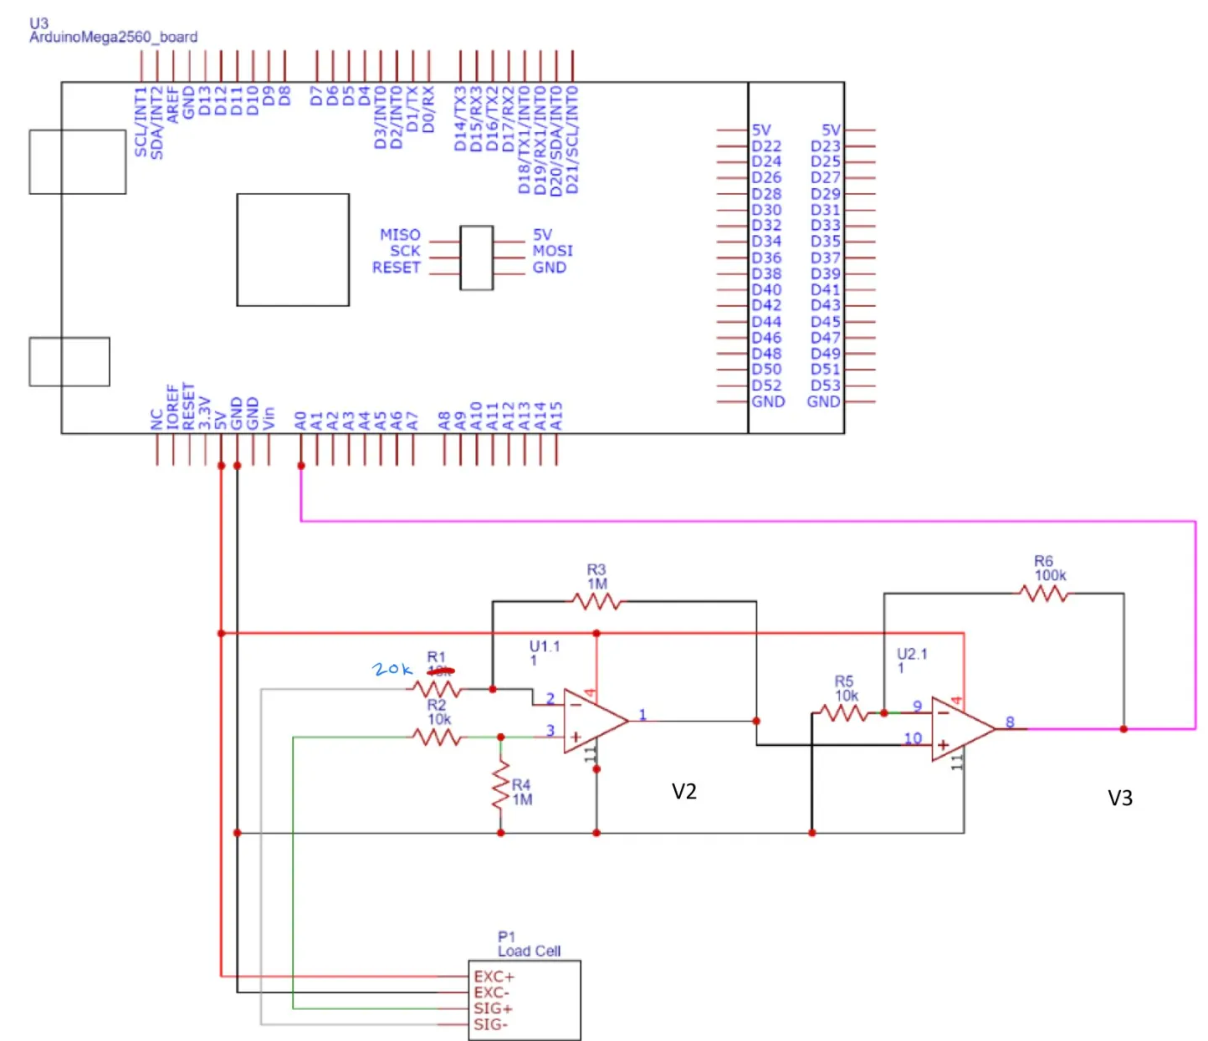
Extend your knowledge drawn schematic^
- A Wheatstone bridge is an electrical circuit that uses four resistors in a specific arrangement to measure small changes in resistance with high precision. The four resistors are arranged in a diamond formation (the bridge), a voltage is applied across one diagonal of the bridge and the output voltage is measured across the other diagonal mid-nodes. If the bridge is balanced, the voltage between the mid-nodes is zero. If even one resistor changes slightly, the bridge becomes unbalanced, and a small differential in voltage occurs. This is used in load cells because the load cell requires converting a mechanical load or force (weight) into an electrical signal. The load cell uses a strain gauge, a piezoresistive element on a deformable structure. When a force is applied on the load cell, the mechanical structure deforms slightly, and the strain gauge’s resistance changes proportional to the deformation. Load cells use 2-4 strain gauges in a Wheatstone bridge so that when the deformation changes their resistances, the Wheatstone bridge detects it and converts it to a change in voltage, which can be the electrical signal output for our sensor.
- As explained earlier, the voltage differential would be very tiny in our strain gauge sensors. The role of the op-amps is to amplify this voltage signal (in our case, in the low millivolts) into a higher voltage value as a proper electrical signal for our other devices or applications. In our case, our op-amps amplified the max millivolt signal of 8mV all the way to 5V. A 5V electrical signal is standard, for example, for PLCs.
- The role of the pressure transducer is to convert pressure detected into an electrical signal. Like the explanation earlier, the principle is the same. A pressure is applied to the sensor (gas, liquid), a structure deforms (in this case a diaphragm or elastic membrane), and strain gauges in the structure deform as well and change their electrical resistance. These strain gauges are once again wired in a Wheatstone bridge so that the small resistance changes convert to small voltage changes, which can now be used as our electrical signal. Then, op-amps are used once again to amplify the voltage change into useful levels.

Conclusion
The force sensor relies on the mechanical deformation of a resistive element (e.g. a strain gauge or force-sensitive resistor) to change its electrical resistance under applied force. When a load is applied, the sensor’s internal element deforms and alters the resistance between its terminals. This lab tested the force sensor using an Arduino and a breadboard circuit for the hardware side, and LabVIEW together with Arduino firmware for the software side. An amplification chain was implemented (first one op-amp stage, then a second) to boost the weak voltage signal from the sensor. The conditioned voltage was continuously monitored and displayed using LabVIEW, and an indicator on the LabVIEW front panel shown the measured voltage. For the final part, a new circuit was made by replacing R1’s 10k ohm resistor with 20k ohm to cut the total gain of the circuit by half. The result was a halved voltage output range.

